DATUP Local Installation Guide

Pharmacy Reengineering



Version 3.0

May 2016

Department of Veterans Affairs

Office of Information and Technology (OIT)

Product Development (PD)

REVISION HISTORY

Each time this manual is updated, the Title Page lists the new revised date and this page describes the changes. No Change Pages document is created for this manual. Replace any previous copy with this updated version.

| **Date** | **Revised Pages** | **Patch Number** | **Description** |
| --- | --- | --- | --- |
| April 5, 2016 | All | N/A | Tech edited John Tyler |
| March 31, 2016 | Many | N/A | Updated references to build number; added backout steps. |
| January, 2016 | All | N/A | Tech edited John Tyler |
| August, 2015 | All | N/A | Updated for DATUP 3.0 Bob Steidl |
| April 27, 2015 | All | N/A | Tech edited and updated for template compliance. John Tyler |
| July 18, 2014 | All | N/A (First Release) | Changed date (month) to reflect real release date  Marella Colyvas |
| June 3, 2014 | All | N/A (First Release) | Fixed pagination  Marella Colyvas |
| May 30, 2014 | All | N/A (First Release) | Added footnote describing relationship between FDB MedKnowledge Framework and FDB-DIF, updated text appropriately. Updated TOC.  Brian Holihan |
| May 28, 2014 | All | N/A (First Release) | Updated images for 508 compliance; changed FDB MedKnowledge Framework back to FDB-DIF. Updated TOC  Brian Holihan |
| May 27, 2014 | All | N/A (First Release) | Updated Revision History format; did a partial search and replace on FDB-DIF (and other similar iterations) to FDB MedKnowledge Framework, though not in the instructions as the tool may not be updated yet. Removed extraneous definitions of FDB.  Brian Holihan |
| May 21, 2014 | i | N/A (First Release) | Updated Revision History  Brian Holihan |
| May 21, 2014 | i, 3, B-1 | N/A (First Release) | Updated Title Page, Corrected Version number in Overview section, minor text edit, added B-1 to Table of Figures.  Brian Holihan |
| May 19, 2014 | All | N/A (First Release) | DBA Corrected Information, minor formatting updates  Alicia Ray, Brian Holihan |
| May 13, 2014 | All | N/A (First Release) | Edits to headings, TOC, references, and footers  Marella Colyvas |
| February 7, 2013 | All | N/A (First Release) | Technical Writer Edits  Marella Colyvas |
| February 5, 2013 | All | N/A (First Release) | Updates to various section for DATUP 2.0  Sachin Sharma |
| February 1, 2013 | All | N/A (First Release) | Incorporated database configuration updates for DATUP 2.0, FDB installation instructions moved to FDB install guide.  Alicia Ray |
| August 27, 2012 | All | N/A (First Release) | Changed formatting and performed edits  Marella Colyvas |
| August 14,2012 | All | N/A (First Release) | Updates to various section to address minor configuration changes  Sachin Sharma |
| May 29,2012 | All | N/A (First Release) | Updated the document to address change request #CR5172 (Image Processing for PPS)  Sachin Sharma |
| December 3, 2010 | All | N/A (First Release) | No changes since last delivery. Updated the version number to reflect the latest release of DATUP.  SwRI |
| November 12, 2010 | All | N/A (First Release) | Updated the document to address change request #CR2942.  SwRI |
| October 8, 2010 | All | N/A (First Release) | Renamed all instances of “PEDTUP” to “DATUP.”  SwRI |
| September 3, 2010 | All | N/A (First Release) | Local PEDTUP Installation Guide: Initial version.  SwRI |

ProPath Template used v1.6, June 2012

TABLE OF CONTENTS

1 Project Scope 1

1.1 Project Description 1

1.2 PRE Project Goals and Objectives 1

1.3 DATUP Background 1

1.4 Related Documents 2

2 Document Overview 3

2.1 Document Background 3

2.2 Overview 3

3 Installation Instructions 5

3.1 Terminology 6

3.2 Assumptions 6

3.3 Database Installation and Configuration 7

3.4 WebLogic Installation Instructions 7

3.4.1 Class Path 7

3.4.2 WebLogic Server Startup Configuration 8

3.4.3 Local JDBC Data Source Configuration 12

3.4.4 Log4j 21

3.4.5 DATUP Configuration Properties 21

3.4.6 DATUP Cleanup Script 21

3.4.7 Deployment 21

4 Upgrade Installation Instructions 31

4.1 Uninstall Previous Release 31

4.2 Deploy New Release 35

4.3 Backout Build 35

5 System Verification 37

5.1 Verification 37

Appendix A A-1

Local DATUP Configuration A-1

Appendix B B-1

Combined DATUP / PECS Architecture B-1

Appendix C: log4j Properties C-1

**LIST OF FIGURES**

Figure 3‑1. WebLogic Console 5

Figure 3‑2. Domain Structure 8

Figure 3‑3. Change Center 8

Figure 3‑4. Summary of Servers 9

Figure 3‑5. Settings for Deployment Server 10

Figure 3‑6. Server Start Tab 11

Figure 3‑7. Activate Changes 12

Figure 3‑8. Domain Structure 13

Figure 3‑9. Change Center 13

Figure 3‑10. Summary of JDBC Data Sources 14

Figure 3‑11. JDBC Data Source Properties 15

Figure 3‑12. Transaction Options 16

Figure 3‑13. Connection Properties 17

Figure 3‑14. Test Database Connection 18

Figure 3‑15. Select Targets 19

Figure 3‑16. Summary of JDBC Data Sources 20

Figure 3‑17. Statement Cache Size Parameter 20

Figure 3‑18. Activate Changes 20

Figure 3‑19. Domain Structure 22

Figure 3‑20. Change Center 22

Figure 3‑21. Deployments 23

Figure 3‑22. Install Application Assistant 23

Figure 3‑23. Locate Deployment to Install and Prepare for Deployment 24

Figure 3‑24. Choose Targeting Style 25

Figure 3‑25. Select Deployment Targets 25

Figure 3‑26. Optional Settings 26

Figure 3‑27. Settings for DATUP 27

Figure 3‑28. Activate Changes 28

Figure 3‑29. Domain Structure 28

Figure 3‑30. Summary of Deployments 29

Figure 3‑31. Start Application Assistant 29

Figure 3‑32. Summary of Deployments – DATUP Deployment Active 30

Figure 4‑1. Domain Structure 31

Figure 4‑2. Change Center 32

Figure 4‑3. Summary of Deployments – Stopping DATUP 32

Figure 4‑4. Force Stop Application Assistant 33

Figure 4‑5. Summary of Deployments – DATUP Deployment Prepared 33

Figure 4‑6. Delete Application Assistant 34

Figure 4‑7. Summary of Deployments – DATUP Deployment Deleted 34

Figure 4‑8. Activate Changes 35

Figure B‑1: Combined DATUP/PECS Architecture Diagram B-2

LIST OF TABLES

Table 3‑1. Terminology 6

# Project Scope

## Project Description

The goal of the VHA Pharmacy Reengineering (PRE) project is to design and develop a re-engineered pharmacy system, incorporating changes that have been made to the Enterprise Architecture and changes in pharmacy business processes. The intent of the PRE program is to ensure that no current system functionality is lost, but that it is either replicated in the new system or replaced by improved process and functionality. While the overall plan is still based on designing and implementing a complete pharmacy system, the scope of the effort has been defined to address a focused subset of the PRE functionality confined to the DATUP process.

## PRE Project Goals and Objectives

The objective of the PRE project is to facilitate the improvement of pharmacy operations, customer service, and patient safety for the VHA. The PRE project will help address the identified goals and vision for the VHA Pharmacy System.

The goal for the PRE project is a seamless and integrated nationally-supported system that is an integral part of the Health*e*Vet-Veterans Health Information Systems & Technology Architecture (VistA) environment. To meet this goal, the PRE project will enhance pharmacy data exchange, as well as clinical documentation capabilities, in a truly integrated fashion to improve operating efficiency and patient safety. Additionally, it will provide a flexible technical environment to adjust to future business conditions and to meet patient needs in the clinical environment. Achieving this goal will enable resolution of current pharmacy issues, improve patient safety, and facilitate long-term process stability.

## DATUP Background

DATUP supports the Medication Order Check Healthcare Application (MOCHA) by performing data source updates. MOCHA conducts order checks using First Databank (FDB) MedKnowledge Framework[1] within the existing VistA pharmacy application. FDB MedKnowledge Framework is a data product that provides the latest identification and safety information on medications. Additionally, FDB provides the latest algorithms used to perform order checks. DATUP processes the data updates associated with FDB MedKnowledge Framework. The order checks performed by MOCHA include:

* Drug-Drug Order Check – Check interactions between two or more drugs, including interaction monographs.
* Duplicate Therapy Order Check – Check for duplicated drug classifications between two or more drugs.
* Drug-Dose Order Check – Check minimum and maximum single doses, verify the dosing schedule, and provide the normal dosing range.

## Related Documents

A complete list of documents relating to the PRE project and the DATUP development effort can be found in the Glossary and Acronym List (Version 5.0, dated September 26, 2008).

# Document Overview

The information contained in this DATUP Local Installation Guide is specific to the DATUP development, which supports the MOCHA component. This section defines the layout of this document and provides an outline of the document structure.

## Document Background

This document details the steps required to install the DATUP software at a local site, the terminology used for the configuration and deployment of the software, and the assumptions for installing the software. Additionally, this document details how to install and configure the database environment. This document accompanies the delivery of the DATUP Local 3.0.00.0058 software release. The DATUP Version Description Document (Version 1.7) is delivered as a companion document to this Installation Guide. Refer to the Version Description Document for more information on the software inventory and versions used in the DATUP Local v3.0.00.0058 software release.

## Overview

The following list provides a brief description of the sections included in this document:

Section 1: Provides introductory material delineating the purpose of the PRE project and the scope of the MOCHA effort

Section 2: Presents an overview of the layout of the document

Section 3:Presents the installation instructions for the DATUP Local v3.0.00.0058 software release

Section 4: Presents verification steps to verify that the installation was successful

Text in a Courier New font indicates WebLogic Console panels or text, commands, and settings that must be typed, executed, or configured to complete the installation.

*(This page included for two-sided copying.)*

# Installation Instructions

The following instructions detail the steps required to perform a *fresh* installation of the DATUP software at a local site. For *upgrade* installation instructions see Section 4. Section 3.1 details the terminology used for the configuration and deployment of the DATUP software. Section 3.2 outlines the assumptions for installing the DATUP software. While the system may be configured to run outside the given assumptions, doing so requires modifications that are not detailed in this document. Section 3.3 describes how to install and configure the DATUP software properly. Finally, Section 3.3 provides an overview of the Database Server component.

In order to understand the installation and verification process, the reader should be familiar with the WebLogic console shown in Figure 3‑1. The WebLogic console is a Web page viewable from any Internet browser; however, Internet Explorer, Version 7, is recommended. The WebLogic console is generally divided into two sections. The left section contains the Change Center, Domain Structure, and other informational panels. The right section displays panels containing additional options or configuration details. Note: With the exception of the Change Center and Domain Structure references, further references to WebLogic console panels refer to panels in the right section of the WebLogic console.

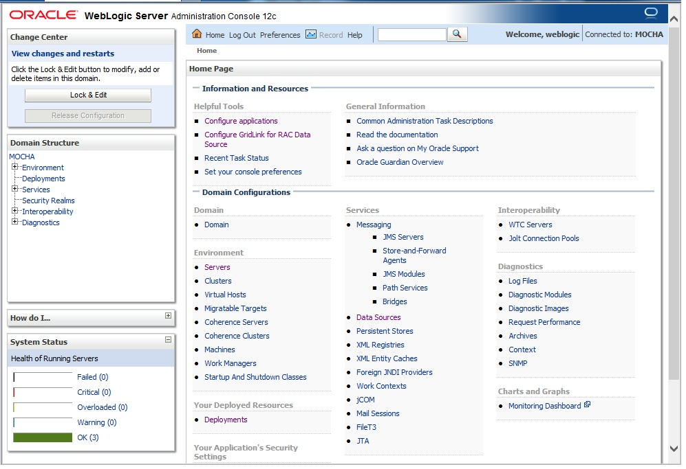

Figure 3‑1. WebLogic Console

## Terminology

In an effort to make these installation instructions as general as possible for installation at any site, a few terms are used throughout the instructions with the intent that they be replaced with site-specific values.

Table 3‑1 contains a list of those terms used only within this document as well as sample site-specific values for each term. Additionally, references to the DATUP-L-1 server may be replaced with the site-specific name of the destination server at the installation site.

Table 3‑1. Terminology

| Term | Definition | Sample |
| --- | --- | --- |
| Database Server | Machine on which Caché is installed and runs | DATUP-L-1-DB |
| Deployment Machine | Site-specific machine on which WebLogic is installed and runs | DATUP-L-1 |
| Deployment Server | WebLogic managed server where DATUP is deployed | LocalPharmacyServer |
| Deployment Server Port | Port on which the Deployment Server is listening | 8010 |
| Deployment Server’s class path directory | Folder location on the Deployment Server where libraries on the class path are located (see WebLogic documentation for instructions on setting a WebLogic managed server’s class path) | /opt/bea/domains/PRE/lib |
| Java Database Connectivity (JDBC) Universal Resource Locator (URL) | URL to connect to Caché database | jdbc:Cache://DATUP-l-1-db:1972/FDB_DIF |

## **Assumptions**

The installation instructions found within this guide are intended to be performed on a clean installation of WebLogic 12.1.1, with a separate managed server to act as the Deployment Server. For details on completing the installation of the following items, please refer to each item’s installation and configuration documentation supplied by Oracle.

For successful deployment of the DATUP software at a site, the following assumptions must be met:

* The Deployment Server is configured and running.
* WebLogic is configured to run with the Java™ Standard Edition Development Kit, Version 1.7+.
* Access to the WebLogic console is by means of any valid administrative user name and password.
* The proper Caché database driver libraries for the chosen deployment environment are present on the class path for the respective Deployment Servers.
* Red Hat Enterprise Linux 5.x operating system is properly installed.
* Domain Name Server (DNS) resolution is configured for the DATUP server.
* The installation instructions are followed in the order that the sections are presented within this Installation Guide.
* FDB-DIF v3.3 database is installed on the Database Server. Installation instructions are provided in FDB-DIF Installation/Migration guide. Contact the PRE Configuration Manager who should be identified on the project’s Technical Services Project Repository (TSPR) site for a copy of the guide and installations/migration scripts.

## Database Installation and Configuration

The FDB MedKnowledge Framework database used by DATUP requires Caché to be successfully installed. The Caché database has specific installation procedures and files for each operating system. Red Hat Linux must be successfully installed prior to installing the Caché database. A successful installation of a Caché database instance is one in which the installation guide procedures are followed, resulting in an error-free installation.

The installation of the Caché database is described in the Caché Installation Guide, Version 2008.2, Section 4, Installing Caché on UNIX and Linux. The standard installation should be used to install the Caché database server software.

For successful deployment of the DATUP v3.0.00.0058 software at a site, the FDB-DIF v3.3 database must be installed. Installation instructions are provided in FDB-DIF Installation/Migration guide. Contact the PRE Configuration Manager who should be identified on the project’s Technical Services Project Repository (TSPR) site for a copy of the guide and installations/migration scripts.

## WebLogic Installation Instructions

The following sections detail the steps required to configure and deploy DATUPonto WebLogic at a local site.

### Class Path

In order for the Caché JDBC data source to be added to the WebLogic configuration, the Caché JDBC driver must first be added to the Deployment Server’s class path. Use the JDBC driver provided within the Caché distribution and the WebLogic documentation to add the driver to the class path.

The local DATUPEnterprise Application Archive (EAR) file contains all the required libraries for the proper functioning of the application. If any other applications have been deployed to the Deployment Server, there may be conflicting third-party libraries in the Deployment Server's class path that will cause DATUPto operate differently than expected. If versions on the Deployment Server’s class path differ from those defined in the DATUP Version Description Document (Version 3.0.00.0058, dated March, 2016), the preferred solution is to remove the library from the Deployment Server's class path. If that is not possible, replace the libraries with the DATUP versions.

### WebLogic Server Startup Configuration

DATUP requires additional arguments added to the WebLogic Server’s Server Start properties. This section details the steps to add the arguments to the server

1. Open and log into the WebLogic console, using an administrative user name and password. The WebLogic console is located at: http://<Deployment Machine>:7001/console.
2. Within the Domain Structure panel found in the left column of the WebLogic console, click on the Services > JDBC > Data Sources node. For reference, see Figure 3‑2.

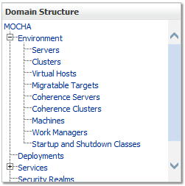

Figure 3‑2. Domain Structure

1. Within the Change Center panel found in the left column of the WebLogic console, click Lock & Edit. For reference, see Figure 3‑3.

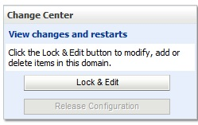

Figure 3‑3. Change Center

1. Click on the server name corresponding to the deployment server in the Summary of Servers panel found in the right column of the WebLogic console. For reference, see Figure 3‑4.

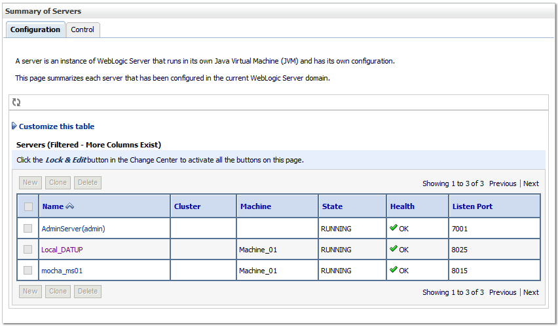

Figure 3‑4. Summary of Servers

1. WebLogic will now display the panel Settings for Deployment Server in the right column of the console, where configuration of the Deployment Server are set. For reference, see Figure 3‑5.

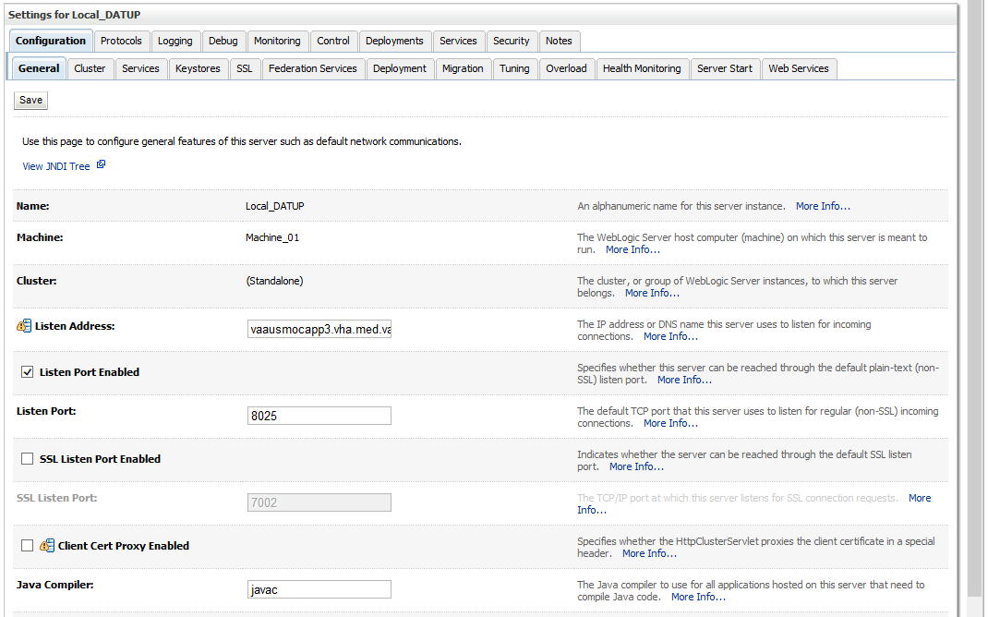

Figure 3‑5. Settings for Deployment Server

1. Click on the Server Start tab.
2. WebLogic will now display the panel Server Start tab in the Settings for Deployment Server in the right column of the console, where configuration of the Deployment Server are set. For reference, see Figure 3‑6.

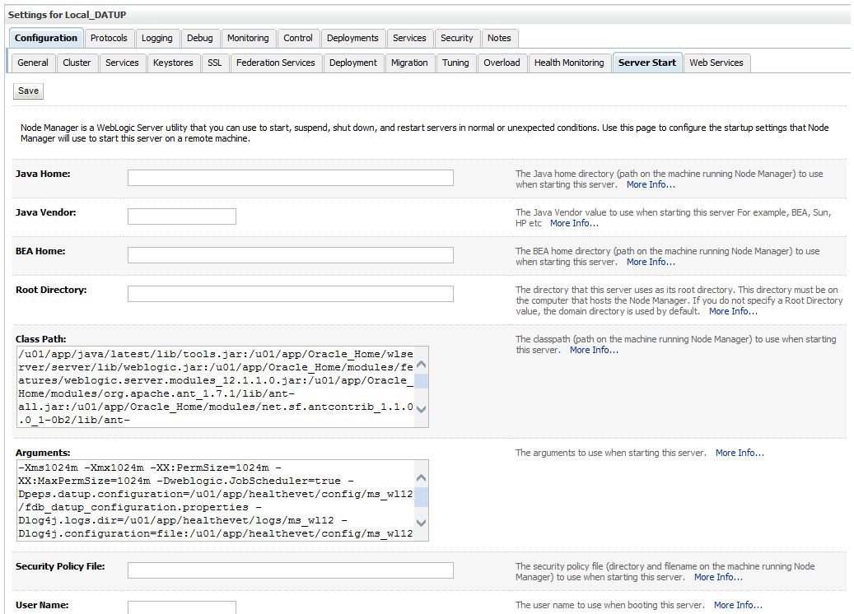

Figure 3‑6. Server Start Tab

1. Insert the following text in the Arguments box:

-Xms1024m

-Xmx1024m

-XX:PermSize=1024m

-XX:MaxPermSize=1024m

-Dweblogic.JobScheduler=true

Also add a arguments for Log4j file and other Log files. (see for reference below, modify path per your server configuration) :-

-Dlog4j.configuration=file: /u01/app/healthevet/config/ms_wl12/log4j.xml

-Dlog4j.logs.dir=/u01/app/healthevet/logs/ms_wl12

-Dpeps.datup.configuration=/u01/app/healthevet/config/ms_wl12/fdb_datup_configuration.properties

1. Click the Save Button
2. Within the Change Center panel in the left column of the WebLogic console, click Activate Changes. For reference, see Figure 3‑7.

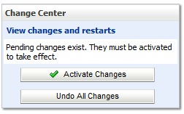

Figure 3‑7. Activate Changes

### Local JDBC Data Source Configuration

DATUPuses a database connection by means of a data source to DIF in order to perform order checks. Complete the following steps to create a new connection pool and data source for DIF.

1. Open and log into the WebLogic console, using an administrative user name and password. The WebLogic console is located at: http://<Deployment Machine>:7001/console.
2. Within the Domain Structure panel found in the left column of the WebLogic console, click on the Services > Data Sources node. For reference, see Figure 3‑8.

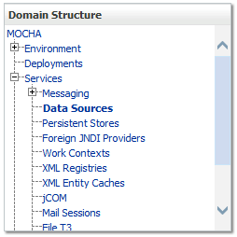

Figure 3‑8. Domain Structure

1. Within the Change Center panel found in the left column of the WebLogic console, click Lock & Edit. For reference, see Figure 3‑9.

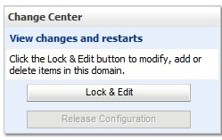

Figure 3‑9. Change Center

1. Click New > Generic Data Source found in the Summary of JDBC Data Sources panel found in the right column of the WebLogic console. For reference, see Figure 3‑10.

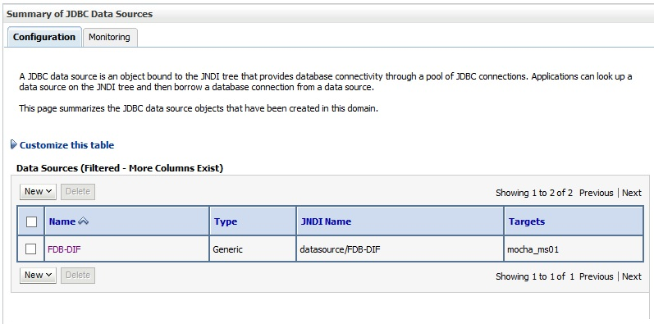

Figure 3‑10. Summary of JDBC Data Sources

1. WebLogic will now display the panel Create a New JDBC Data Source in the right column of the console, where details of the new data source are set. For reference, see Figure 3‑11.

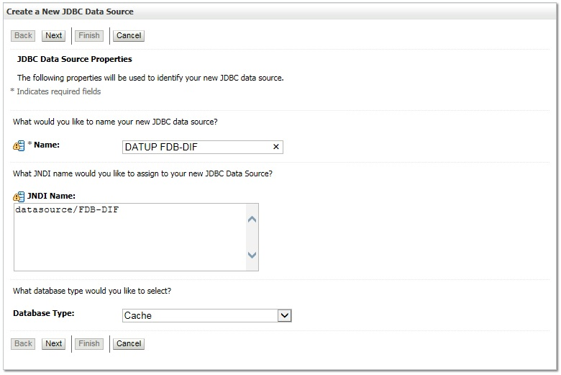

Figure 3‑11. JDBC Data Source Properties

1. For the Name, type DATUP FDB-DIF.
2. For the JNDI Name, type datasource/FDB-DIF.
3. For the Database Type, select Cache.
4. Click Next.
5. For the Database Driver, verify that Intersystems’s Cache Driver (Type 4) Versions: Any is selected.
6. Click Next.
7. WebLogic will now display the panel Transaction Options in the right column of the console, where the transaction attributes for this data source are set. For reference, see Figure 3‑12.

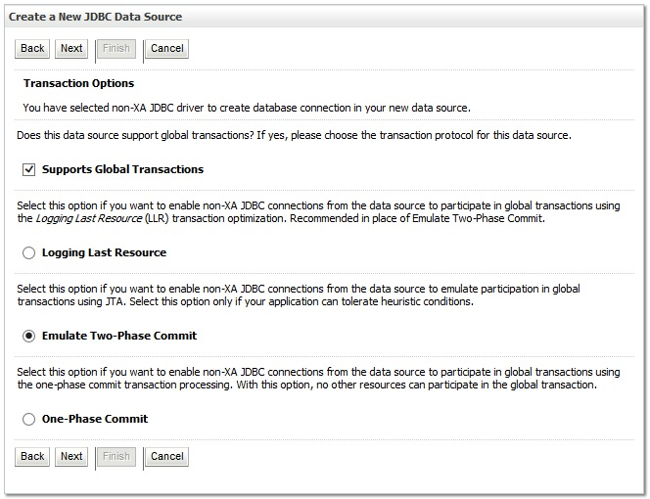

Figure 3‑12. Transaction Options

1. Select the Emulate Two-Phase Commit radio button.
2. Click Next.
3. WebLogic will now display the panel Connection Properties in the right column of the console, where the connection pool attributes are set. For reference, see Figure 3‑13.

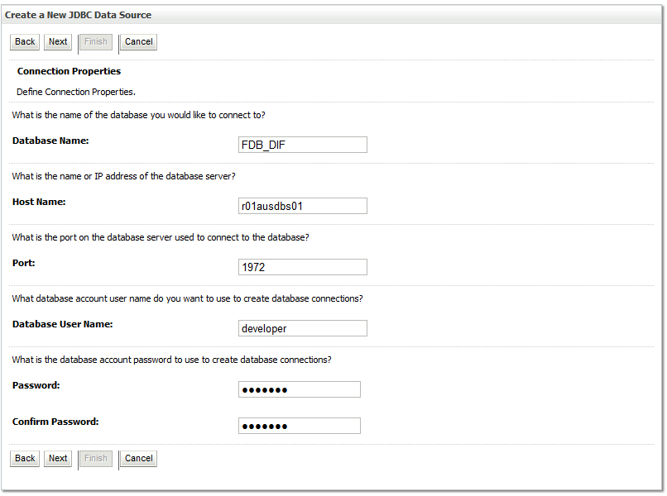

Figure 3‑13. Connection Properties

1. For Database Name, type the name of the Caché database to which DATUP will connect. For example, FDB_DIF.
2. For Host Name, type the name of the machine on which Caché is running. For example, r01ausdbs01.
3. For Port, type the port on which Caché is listening. For example, 1972.
4. For Database User Name, type the user’s name to connect to the FDB database. For example, developer. The user entered should be the same as configured during the FDB database setup using the FDB-DIF Installation/Migration guide. Verify username and password with the DBA.
5. For Password and Confirm Password, type the password for the user given previously. For example, pharmacy.
6. Click Next.
7. WebLogic will now display the panel Test Database Connection in the right column of the console, where the new data source can be tested. For reference, see Figure 3‑14.

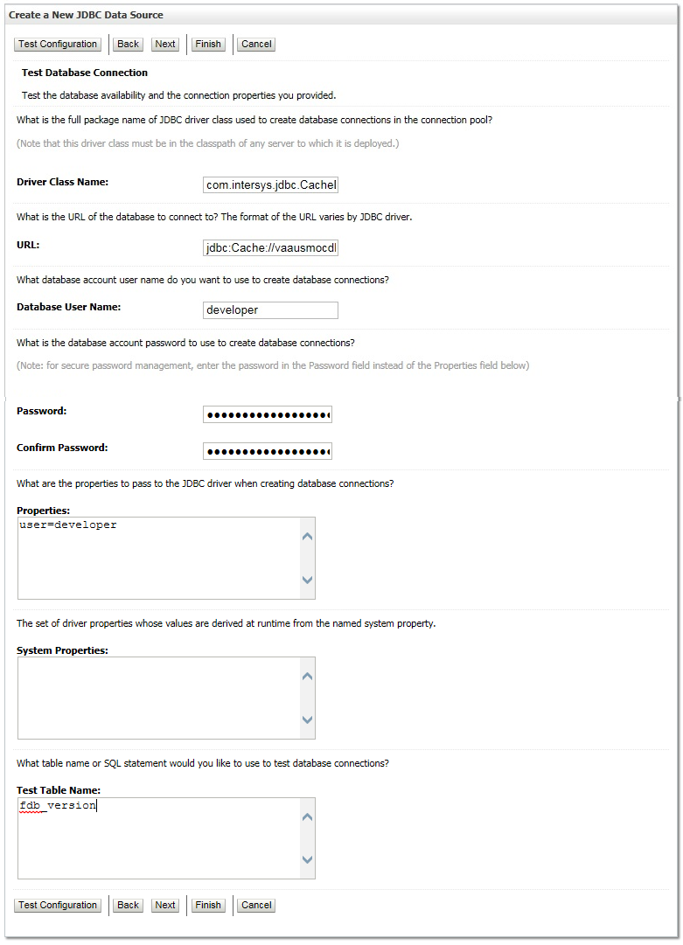

Figure 3‑14. Test Database Connection

1. Leave all values as set by default, with the exception of Test Table Name. For this attribute, type fdb_version.
2. Click Next.
3. WebLogic will now display the panel Select Targets in the right column of the console, where the target server is selected for the new data source. For reference, see Figure 3‑15.

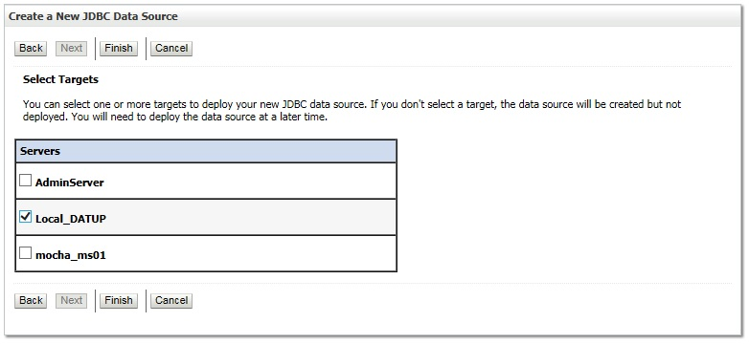

Figure 3‑15. Select Targets

1. Select the Deployment Server as the target. For example, Local_DATUP.
2. Click Finish.
3. WebLogic will now display the panel Summary of JDBC Data Sources in the right column of the console, where the newly created data source is displayed. For reference, see Figure 3‑16.

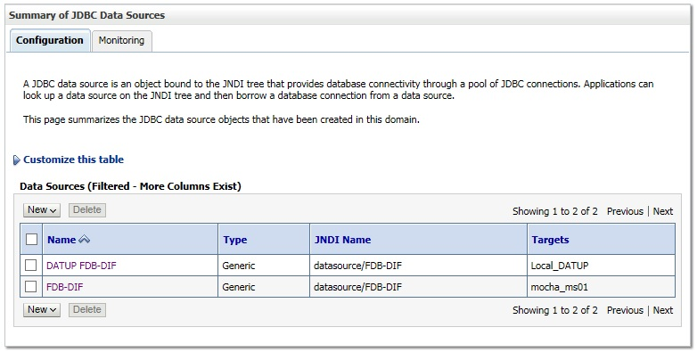

Figure 3‑16. Summary of JDBC Data Sources

Prepared statement caching will need to be turned off to work around a defect in Cache. To do so, select the newly created data source, DATUP FDB-DIF, and navigate to the Connection Pool tab. Change the Statement Cache Size parameter to 0 then click save. For reference, see Figure 3‑17.

Statement Cache Size Parameter

Figure 3‑17. Statement Cache Size Parameter

1. Within the Change Center panel in the left column of the WebLogic console, click Activate Changes. For reference, see Figure 3‑18.



Figure 3‑18. Activate Changes

### Log4j

DATUP uses Log4j to provide debug and error logs. Although the application will function without Log4j installed, using it can be helpful to troubleshoot potential issues. Because DATUP can operate without Log4j configured, all instructions within this section are only required if debugging deployed code.

To install Log4j, the log4j JAR must be placed on the Deployment Server’s class path and the log4j_datup.xml must be edited to include the DATUP appenders and loggers. Complete the following instructions to place the Log4j library on the Deployment Server’s class path.

1. Copy log4j-1.2.17.jar to server/lib folder where WebLogic is installed - /u01/app/Oracle_Home/wlserver/server/lib, for example. Note: If log4j is already installed, the jar file will already be on the server.
2. Configure WebLogic to include the Log4j library in the Deployment Server’s class path. Please refer to the WebLogic documentation provided by Oracle for completing this step.
3. Add the follow argument on the Server Start tab of the DATUP Deployment Server. Refer to the steps in section 3.4.2, if necessary: **-Dweblogic.log.Log4jLoggingEnabled=true**
4. Create the log folder defined in the Deployment Server arguments. For example, /u01/app/Oracle_Home/user_projects/domains/mocha/DATUPLogs. Without this folder, Log4j will not be able to create the log files specified in the DATUP configuration.
5. Create the log4j_datup.xml file that is located in the path specified in the Deployment Server arguments.
6. Configure the log4j.xml using Appendix C as a reference.
7. Restart the Deployment Server to load the Log4j configuration.

For further information, reference http://wiki.apache.org/logging-log4j/Log4jXmlFormat.

***Note:*** *Due to policy constraints, this document cannot support live links. Copy and paste the above link into your browser.*

### DATUP Configuration Properties

In order to use the DATUP component, a configuration file must be configured for each WebLogic deployment. The location of this file was configured in Section 3.4.2 and is by default fdb_datup_configuration.properties. This file is self documenting and contains the list of configurable properties for DATUP. See Appendix A for a sample version.

### DATUP Cleanup Script

DATUP creates temporary zip files during the update process. Create a cron job to remove /tmp/datup*.zip files once a day.

### Deployment

The following steps detail the deployment of the DATUP application at a local site. Prior to completing these steps, the WebLogic class path, the WebLogic database configurations, and the Deployment Server must be restarted to load the changed configuration. Please refer to Sections 3.4.1 and 3.4.2 for instructions concerning these configuration items. Complete the following steps to deploy DATUP:

1. Open and log into the WebLogic console. This is located at: http://<Deployment Machine>:7001/console.
2. Within the Domain Structure panel in the left column of the WebLogic console, click the Deployments node. For reference, see Figure 3‑19.

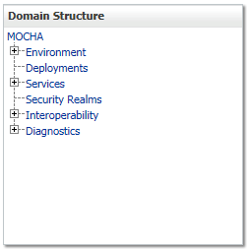

Figure 3‑19. Domain Structure

1. Within the Change Center panel in the left column of the WebLogic console, click Lock & Edit. For reference, see Figure 3‑20.



Figure 3‑20. Change Center

1. Click Install found in the Deployments panel in the right column of the WebLogic console. For reference, see Figure 3‑21.

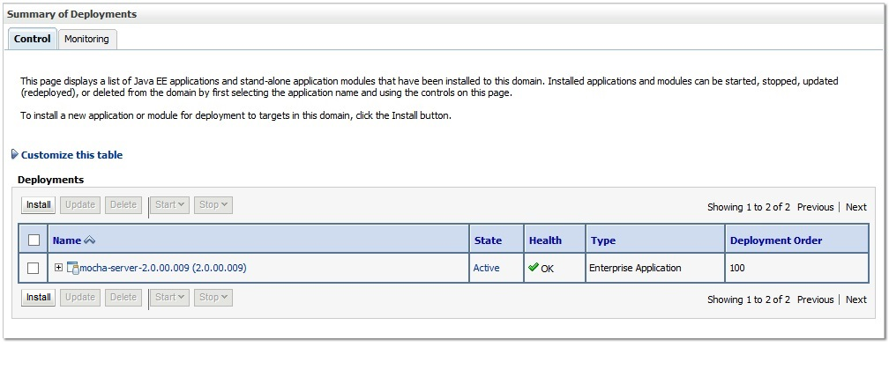

Figure 3‑21. Deployments

1. WebLogic will now display the panel Install Application Assistant in the right column of the console, where the location of the DATUP deployment will be found. For reference, see Figure 3‑22.

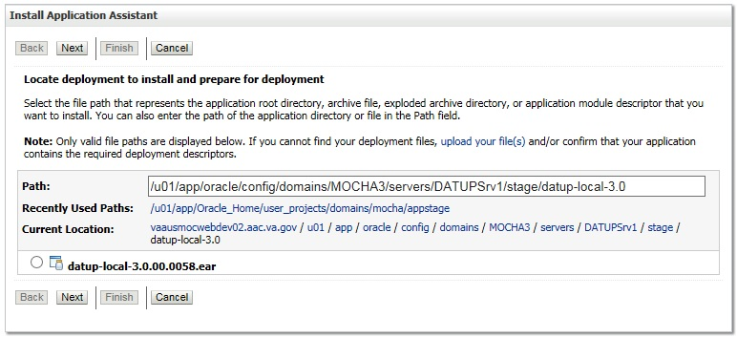

Figure 3‑22. Install Application Assistant

1. Select the DATUP deployment, select the DATUP.local.3.0.00.0032.ear file.
   * 1. If the DATUP deployment has already been transferred to the Deployment Machine, navigate to the deployment file location using the links and file structure displayed within the Location panel within the Install Application Assistant in the right column of the console. For reference, see Figure 3‑23.

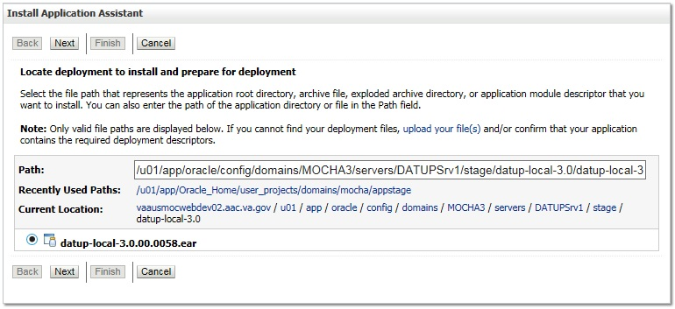

Figure 3‑23. Locate Deployment to Install and Prepare for Deployment

* + 1. If the DATUP deployment has not been transferred to the Deployment Machine:
       1. Click on the upload your file(s) link in the Install Application Assistant panel in the right section of the console. For reference, see Figure 3‑23.
       2. Click the Deployment Archive Browse to see the Choose file dialogue used to select the Deployment Archive.
       3. Click Next in the Upload a Deployment to the admin server panel in the right column of the WebLogic console to return to the Locate deployment to install and prepare for deployment panel within the Install Application Assistant.

1. Once the DATUP deployment is located and selected, click Next.
2. WebLogic will now display the panel Choose targeting style within the Install Application Assistant in the right column of the console. Leave the default value selected, Install this deployment as an application, and click Next. For reference, see Figure 3‑24.

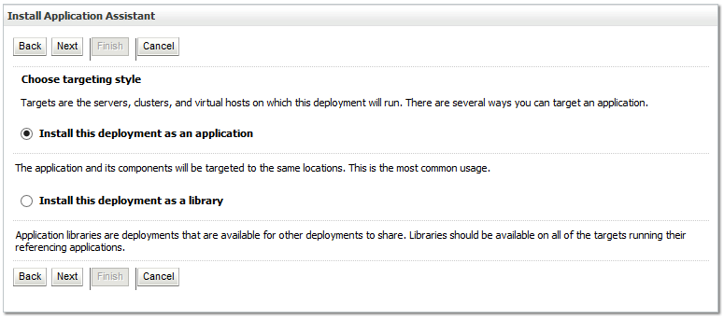

Figure 3‑24. Choose Targeting Style

1. Within the Install Application Assistant in the right column of the console, WebLogic will now display the panel Select deployment targets, where the Deployment Server will be selected as the target in the next step. For reference, see Figure 3‑25.

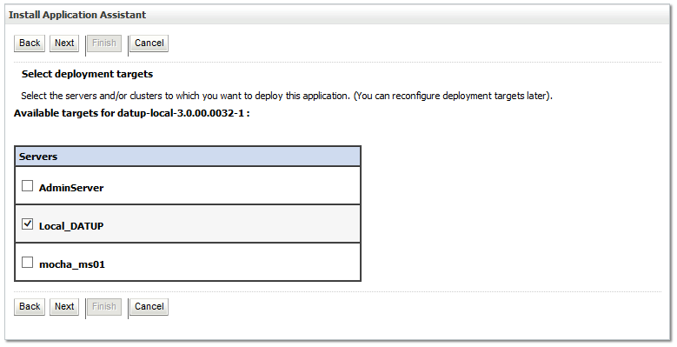

Figure 3‑25. Select Deployment Targets

1. For the Target, select the Deployment Server. For example, Local_DATUP.
2. Click Next.
3. Within the Install Application Assistant, WebLogic will now display the panel Optional Settings in the right column of the console, where the name of the deployment and the copy behavior are chosen. For reference, see Figure 3‑26.

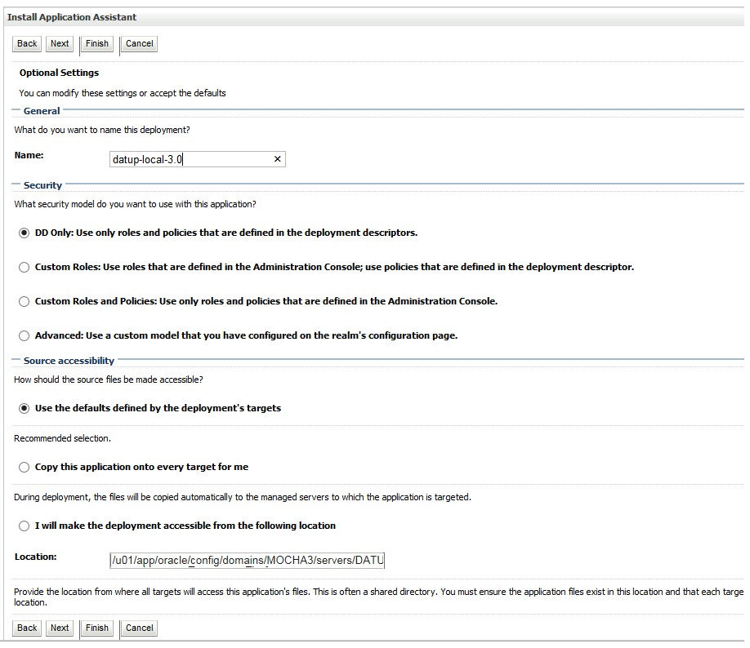

Figure 3‑26. Optional Settings

1. Enter the Name for the deployment. For example, datup-local-3.0.
2. Verify that the following default option for Security is selected:

DD Only: Use only roles and policies that are defined in the deployment descriptors.

1. Verify that the following default option for Source accessibility is selected:

Use the defaults defined by the deployment's targets.

1. Click Next.
2. Within the Install Application Assistant in the right column of the console WebLogic will now display the panel Review your choices and click Finish, which summarizes the steps completed above.
3. Verify that the values match those entered in Steps 1 through 17 and click Finish.
4. WebLogic will now display the panel Settings for Local DATUP, in the right column of the console, where the values previously entered are available as well as a setting to change the deployment order. For reference, see Figure 3‑27.

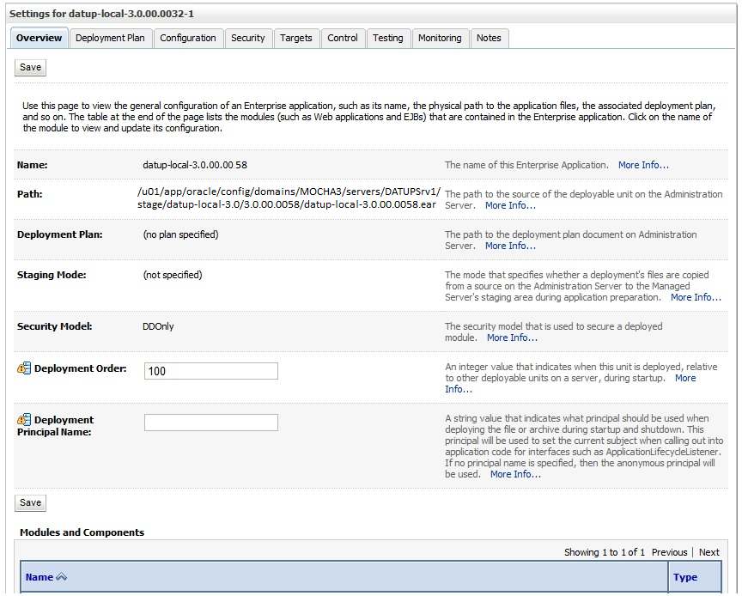

Figure 3‑27. Settings for DATUP

1. Leave all the values as defaulted by WebLogic and click Save.
2. Within the Change Center panel in the left column of the WebLogic console, click Activate Changes. For reference, see Figure 3‑28.

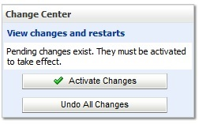

Figure 3‑28. Activate Changes

1. Within the Domain Structure panel in the left column of the WebLogic console, click the Deployments node. For reference, see Figure 3‑29.

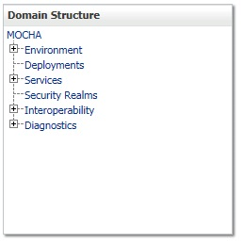

Figure 3‑29. Domain Structure

1. WebLogic will now display the panel Summary of Deployments in the right column of the console, where all deployments for the WebLogic domain are listed. For reference, see Figure 3‑30.

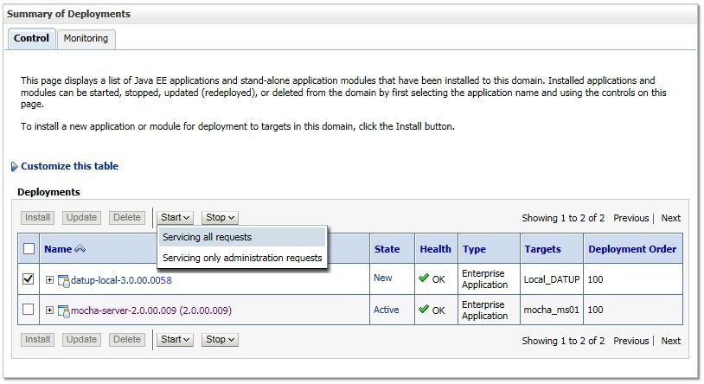

Figure 3‑30. Summary of Deployments

1. Select the previously deployed DATUP deployment, click Start, and then select Servicing all requests from the drop-down list box.
2. WebLogic will now display the panel Start Application Assistant in the right column of the console for confirmation to start servicing requests. For reference, see Figure 3‑31.

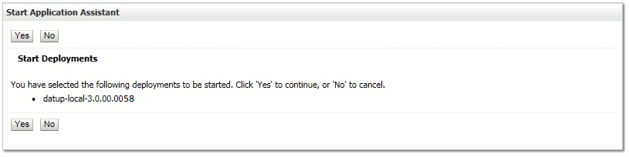

Figure 3‑31. Start Application Assistant

1. Click Yes in the Start Application Assistant panel in the right column of the WebLogic console.
2. WebLogic now returns to the Summary of Deployments panel in the right column of the console. For reference, see Figure 3‑32.

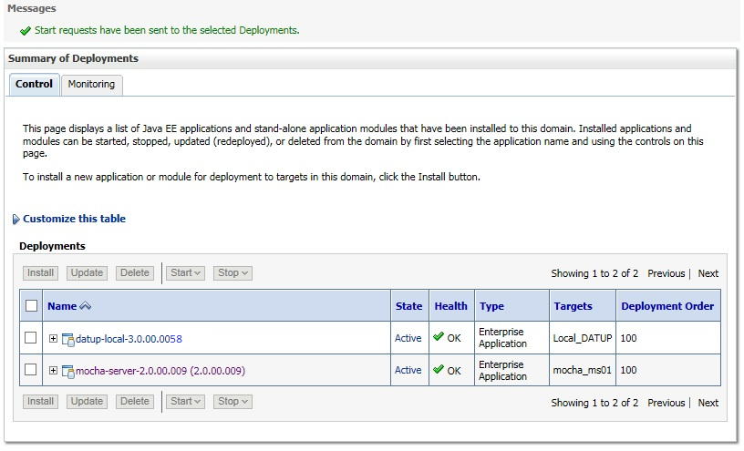

Figure 3‑32. Summary of Deployments – DATUP Deployment Active

1. Verify that the State of the DATUP deployment is Active.

# Upgrade Installation Instructions

The following instructions detail the steps required to perform an installation of a release for the DATUP software, when an existing release is already deployed at a local site. These steps assume a fresh installation has been completed, following the steps in Section 3.

## Uninstall Previous Release

The following steps detail the un-installation of the DATUP application. Prior to completing these steps, the DATUP application must have been deployed following the steps in Section 3. Complete the following steps to un-deploy DATUP at a local site:

1. Open and log into the WebLogic console. This is located at: http://<Deployment Machine>:7001/console.
2. Within the Domain Structure panel in the left column of the WebLogic console, click the Deployments node. For reference, see Figure 4‑1.

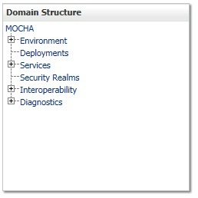

Figure 4‑1. Domain Structure

1. Within the Change Center panel in the left column of the WebLogic console, click Lock & Edit. For reference, see Figure 4‑2.



Figure 4‑2. Change Center

1. WebLogic will now display the panel Summary of Deployments in the right column of the console, where all deployments for the WebLogic domain are listed. For reference, see Figure 4‑3.

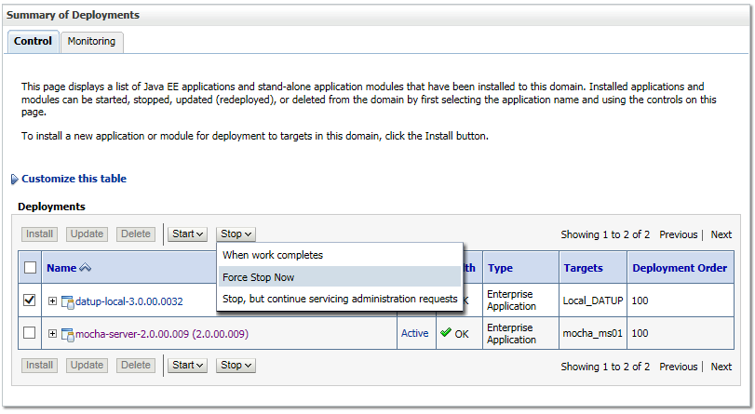

Figure 4‑3. Summary of Deployments – Stopping DATUP

1. Select the previously deployed DATUP deployment, click Stop, and then select Force Stop Now from the drop-down list box.
2. WebLogic will now display the panel Force Stop Application Assistant in the right column of the console for confirmation to start servicing requests. For reference, see Figure 4‑4.

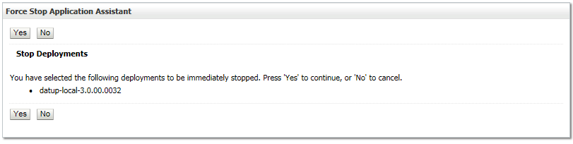

Figure 4‑4. Force Stop Application Assistant

1. Click Yes in the Force Stop Application Assistant panel in the right column of the WebLogic console.
2. WebLogic now returns to the Summary of Deployments panel in the right column of the console. For reference, see Figure 4‑5.

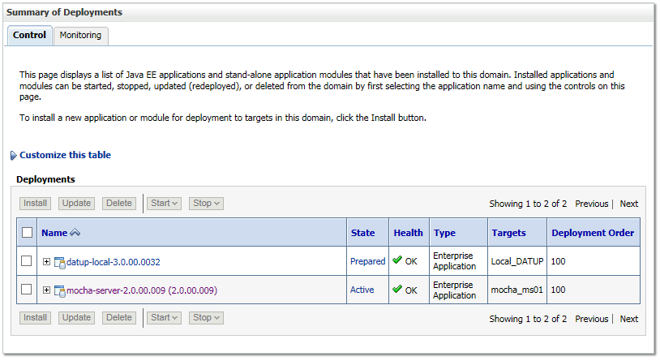

Figure 4‑5. Summary of Deployments – DATUP Deployment Prepared

1. Verify that the State of the DATUP deployment is Prepared.
2. Select the previously deployed DATUP deployment, and then click Delete.
3. WebLogic will now display the panel Delete Application Assistant in the right column of the console for confirmation to start servicing requests. For reference, see Figure 4‑6.

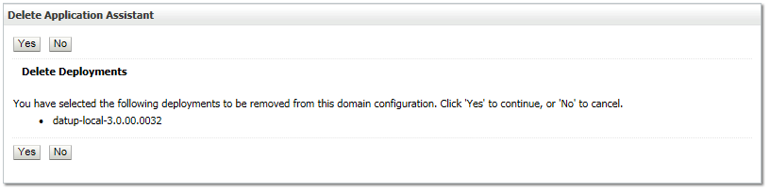

Figure 4‑6. Delete Application Assistant

1. Click Yes in the Delete Application Assistant panel in the right column of the WebLogic console.
2. WebLogic now returns to the Summary of Deployments panel in the right column of the console. For reference, see Figure 4‑7.

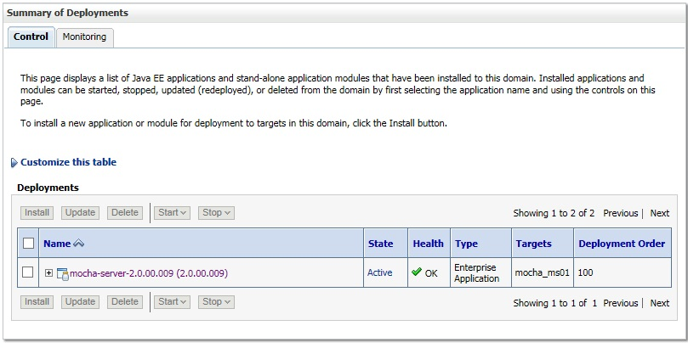

Figure 4‑7. Summary of Deployments – DATUP Deployment Deleted

1. Verify that the DATUP deployment is deleted and no longer present.
2. Within the Change Center panel in the left column of the WebLogic console, click Activate Changes. For reference, see Figure 4‑8.



Figure 4‑8. Activate Changes

## Deploy New Release

To deploy the new release, follow the same deployment steps found in Section 3.4.7.

## Backout Build

To backout the current DATUP build, follow the steps in Section 4.1 to uninstall the build. Then, follow the steps in Section 3.4.7 to deploy the previous build.

*(This page included for two-sided copying.)*

# System Verification

The following section will verify that the DATUP system is up and running at a local site.

## Verification

To verify that a DATUP installation is up and running at a local site, navigate a web-browser to the logs directory on the server, for example, http://datup-l-1/logs/LocalDatupServer/logs.

Verify that the peps.log file has an entry indicating the next scheduled run time for the DATUP application. The peps.log entry looks like:

18 Aug 2015 09:31:29 AM DEBUG [gov.va.med.pharmacy.peps.updater.common.utility.DifUpdateScheduler:scheduleNextTimer] Next scheduled DIF update time: Wed, 08/19/2015, 09:30:00 AM, CDT

This line indicates that the system is running.

*(This page included for two-sided copying.)*

Appendix A

Local DATUP Configuration

This appendix provides DATUP configuration file examples based on the baseline fdb_datup_configuration.properties file. Configure the parameters in this file to match the settings of the particular environment into which you are installing. The sftp.hostname, sftp.port, sftp.username, sftp.password, sftp.base.directory, and sftp.fdb.directory much match the configuration of the sftp server.

The file.name.fragment and file.search.type should be configured to match the environment in which DATUP is being installed.

**Example National DATUP Configuration File**

###################################################

#------------------- Scheduler -------------------

###################################################

###################################################

# Scheduled nightly update time (military time).

#

# For example, "0230" schedules the nightly update

# for 2:30 am.

#

# *This parameter applies to National and Local.

###################################################

scheduled.time=0630

###################################################

#------------------- sFTP Server -------------------

###################################################

###################################################

# SFTP server hostname

#

# Specify the SFTP server hostname.

#

# *This parameter applies to National and Local.

###################################################

sftp.hostname=vaauspresftp01.aac.va.gov

###################################################

# SFTP server port number

#

# Specify the SFTP server port number.

#

# *This parameter applies to National and Local.

###################################################

sftp.port=22

###################################################

# SFTP server username/password.

#

# Specify the anonymous account username/password.

#

# *These parameters apply to National and Local.

###################################################

sftp.username=presftp

sftp.password=password

###################################################

# SFTP server working directory

#

# Specify the SFTP working directory, relative to

# the SFTP root directory.

#

# *This parameter applies to National and Local.

###################################################

sftp.base.directory=/home/presftp/pecs_preprod/

###################################################

# Pending FDB-DIF update storage directory.

#

# Specify the pending directory, relative to the

# working directory, to the location where FDB-DIF

# full, incremental, and custom ZIP files will be

# placed for processing.

#

# *This parameter applies to National and Local.

###################################################

sftp.fdb.directory=/home/presftp/pecs_preprod/fdb_dif

###################################################

# File Name Fragment

#

# Specify the fragment of the file name to be used when searching for files to process.

# Production Environment value of "UPD"

# All Other Environments value of "I"

#

# *The search is case insensitive.

# *This parameter is used in conjunction with File Search Type (file.search.type)

# *This parameter applies to National.

###################################################

#file.name.fragment=UPD

file.name.fragment=I

###################################################

# File Search Type

#

# Specify the search type that should be used.

#

# Production Environment value of "contains"

# All Other Environments value of "starts_with"

#

# *This parameter is used in conjunction with File Name Fragment (file.name.fragment)

# *This parameter applies to National.

###################################################

#file.search.type=contains

file.search.type=starts_with

###################################################

#------------------- FDB DIF ---------------------

###################################################

###################################################

# Number of random FDB-DIF verification tests

#

# Specify the number of random FDB-DIF verification

# tests to run. 10 is a reasonable number. However,

# do not specify a large number as it will cause an

# unacceptable delay for processing new VistA order

# checks during that time.

#

# *This parameter applies to National and Local.

###################################################

fdb.verification.test.count=5

###################################################

# FDB Comparison Report Flag

#

# This property sets the default value for a boolean

# JNDI resource that will be created on the Weblogic

# Domain at startup.

# This boolean value (or flag) will be used by both

# Datup National and PECS to coordinate the processing

# of fdb files so PECS can make appropriate use

# such files before they are deleted by DATUP.

#

# *If this property is not defined, the default value

# will be set to false.

# *This parameter applies to National.

###################################################

fdb.comparison.report.created.flag=false

###################################################

#fdb.flag.provider.url

#

# Specifies the URL of the WebLogic Server that

# provides the naming context where the

# fdb_comparison_report_created_flag resource resides.

# i.e. t3://servername:port (t3 is Weblogic's protocol)

# This property is also defined in PECS, so the

# value on both properties should be the same.

# *This parameter applies to National.

###################################################

fdb.flag.provider.url=t3://vaauspecapp93.aac.va.gov:8007

###################################################

# FDB wait time for PECS run

#

# Specify the number of minutes that DATUP will

# wait for PECS to generate its FDB Customization

# report before trying to process the FDB-DIF

# files again.

#

# Default value will be 20 minutes

# *This parameter applies to National.

###################################################

fdb.pecs.wait.time=180

###################################################

#------------------- Email Server -----------------

###################################################

###################################################

# Email server hostname

#

# *This parameter applies to National and Local.

###################################################

email.hostname=SMTP.VA.GOV

###################################################

# Email sender name

#

# For example, "noreply@va.gov".

#

# *This parameter applies to National and Local.

###################################################

email.sender=PECS_PreProd_AITC@med.va.gov

###################################################

# Email username/password

#

# May be necessary to relay email.

#

# *These parameters apply to National and Local.

###################################################

email.username=

email.password=

###################################################

# Email list for success notifications

#

# Include individuals that should be notified about

# successful FDB/FDB-Custom updates.

#

# *This parameter applies to National and Local.

###################################################

email.list.success=SDDPREArch@med.va.gov

###################################################

# Email list for failure notifications

#

# Include individuals that should be notified about

# failed FDB/FDB-Custom updates.

#

# *This parameter applies to National and Local.

###################################################

email.list.failure=SDDPREArch@med.va.gov

###################################################

# Email list for available update notifications

#

# Include individuals that should be notified about

# available FDB/FDB-Custom updates once they are

# applied and tested and National. This list should

# include the local site managers.

#

# *This parameter applies to National.

###################################################

email.list.update.available=SDDPREArch@med.va.gov

###################################################

#------------------- Locality -----------------

###################################################

###################################################

# Regional Data Center (RDC) name

#

# Specify the name of the RDC or leave blank if

# this installation is not part of a RDC.

#

# *This parameter applies to Local.

###################################################

locality.rdc.name=

###################################################

# Site number(s)

#

# Specify the site number(s) for this installation.

# If more than one site is associated with this

# installation, separate the site numbers with a

# comma (e.g., 423,512,211).

#

# *This parameter applies to Local.

###################################################

locality.site.number=

###################################################

# Number of retained FDB-DIF incremental archives

#

# Due to potential site outages, it is necessary

# to retain a certain number of FDB-DIF archives.

#

# *This parameter applies to National.

###################################################

fdb.retention=20

###################################################

# Number of statements to batch before commit

#

# Specify the number of statements to batch before

# a commit to the database. This value is database

# vendor and JDBC driver dependent. A reasonable

# batch size is 500. However, tests show that Cache

# may throw system errors with a batch size greater

# than 200.

#

# Specify a batch size of 0 to disable batching. A

# single commit will be issued at the end of the

# incremental update.

#

# *This parameter applies to National and Local.

###################################################

fdb.batch.commit.size=0

###################################################

#------------------- IMAGE PROCESSING--------------

###################################################

image.processing.national=TRUE

image.processing.local=FALSE

###################################################

# The location where the image files will be stored

#

#

# *This parameter applies to National only

###################################################

image.directory.national=/tmp/imaging/

###################################################

# The location where the image files will be stored

#

#

# *This parameter applies to local only

###################################################

image.directory.local=/tmp/imaging/

###################################################

# The emai to send to names or group

#

#

# *This parameter applies to National only

###################################################

image.email.sendto.national=SDDPREArch@med.va.gov

###################################################

# The emai to send to names or group

#

#

# *This parameter applies to local only

###################################################

image.email.sendto.local=SDDPREArch@med.va.gov

Appendix B

Combined DATUP / PECS Architecture

This appendix provides the combined DATUP / PECS architecture diagram for reference. The combined logical system components are:

1. DATUP – Implements the FDB-DIF update business logic.
2. Scheduler – Background process for scheduling DATUP.
3. WebLogic – Application server environment.
4. Configuration File – Defines the DATUP configuration settings.
5. SFTP Server – SFTP Server that hosts the FDB-DIF update archives.
6. Email Server – Email relay server.
7. PECS – Implements the FDB-Custom drug business logic.
8. CT Staging Database – Stores PECS FDB-Custom modifications.
9. DATUP Database – Stores DATUP site update history.
10. FDB-DIF Database – Stores the FDB-DIF drug database.

Figure B**−**1 illustrates the logical system components for the National and Local environments. The National components are responsible for verifying and publishing FDB-DIF and FDB-Custom updates to the Anonymous FTP Server. The Local components then consume and apply the verified updates in an automated manner.

Combined DATUP PECS architecture diagram. 

Figure B‑1: Combined DATUP/PECS Architecture Diagram

# Appendix C: log4j Properties

<?xml version="1.0" encoding="UTF-8" ?>

<!DOCTYPE log4j:configuration SYSTEM "log4j.dtd">

<log4j:configuration xmlns:log4j="http://jakarta.apache.org/log4j/">

<appender name="PepsAppender" class="org.apache.log4j.RollingFileAppender">

<param name="File" value="log/peps.log"/>

<param name="Append" value="false"/>

<param name="MaxFileSize" value="5000KB" />

<param name="MaxBackupIndex" value="5"/>

<layout class="org.apache.log4j.PatternLayout">

<param name="ConversionPattern" value="%d{dd MMM yyyy hh:mm:ss a} %-5p [%c:%M] %m%n"/>

</layout>

</appender>

<appender name="SpringAppender" class="org.apache.log4j.RollingFileAppender">

<param name="File" value="log/spring.log"/>

<param name="Append" value="false"/>

<param name="MaxBackupIndex" value="10"/>

<layout class="org.apache.log4j.PatternLayout">

<param name="ConversionPattern" value="%d{dd MMM yyyy hh:mm:ss a} %-5p [%c:%M] %m%n"/>

</layout>

</appender>

<logger name="org.springframework" additivity="false">

<level value="error" />

<level value="error" />

<appender-ref ref="SpringAppender"/>

</logger>

<logger name="gov.va.med.pharmacy.peps" additivity="false">

<level value="debug" />

<appender-ref ref="PepsAppender"/>

</logger>

<root>

<priority value="debug" />

<appender-ref ref="SpringAppender"/>

<appender-ref ref="PepsAppender"/>

</root>

</log4j:configuration>

1. At the time of development, this product was known as FDB Drug Information Framework (commonly abbreviated as FDB-DIF). The references to FDB-DIF in this manual are necessary due to previously completed code and instructions that could not be changed to match the new product name.